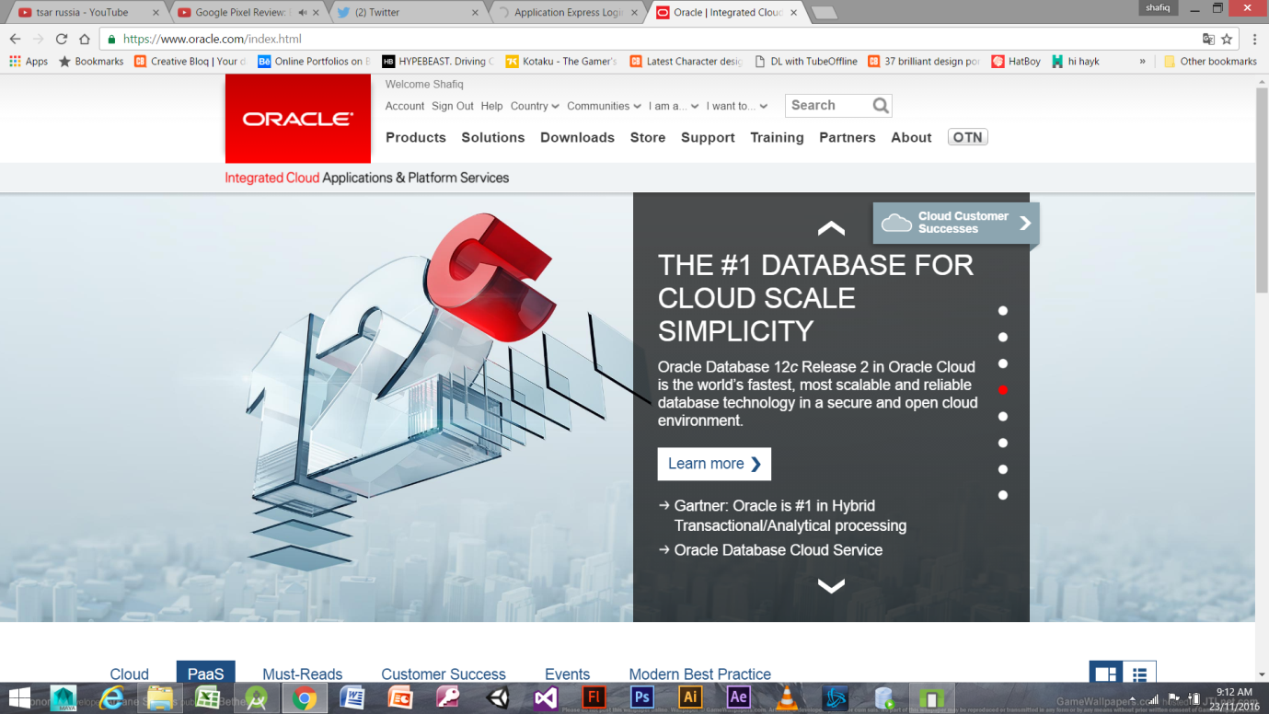

STEP 1-GO TO ORACLE WEBSITE AND SIGN UP,

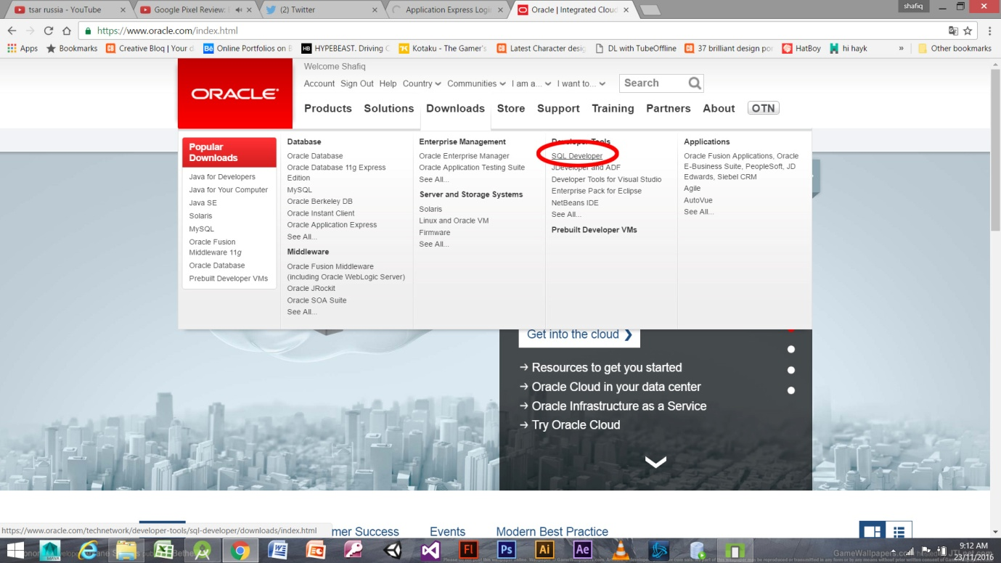

STEP 2-GO TO DOWNLOADS AND DOWNLOAD SQL DEVELOPER

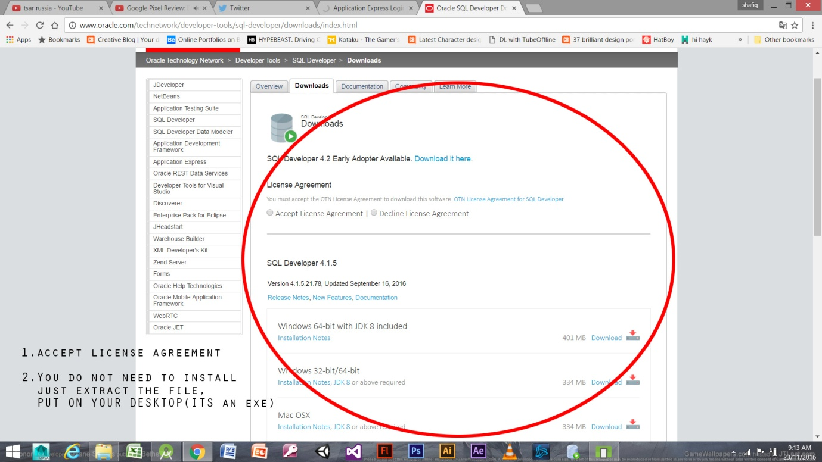

STEP 3-ACCEPT LICENSE AND DOWNLOAD

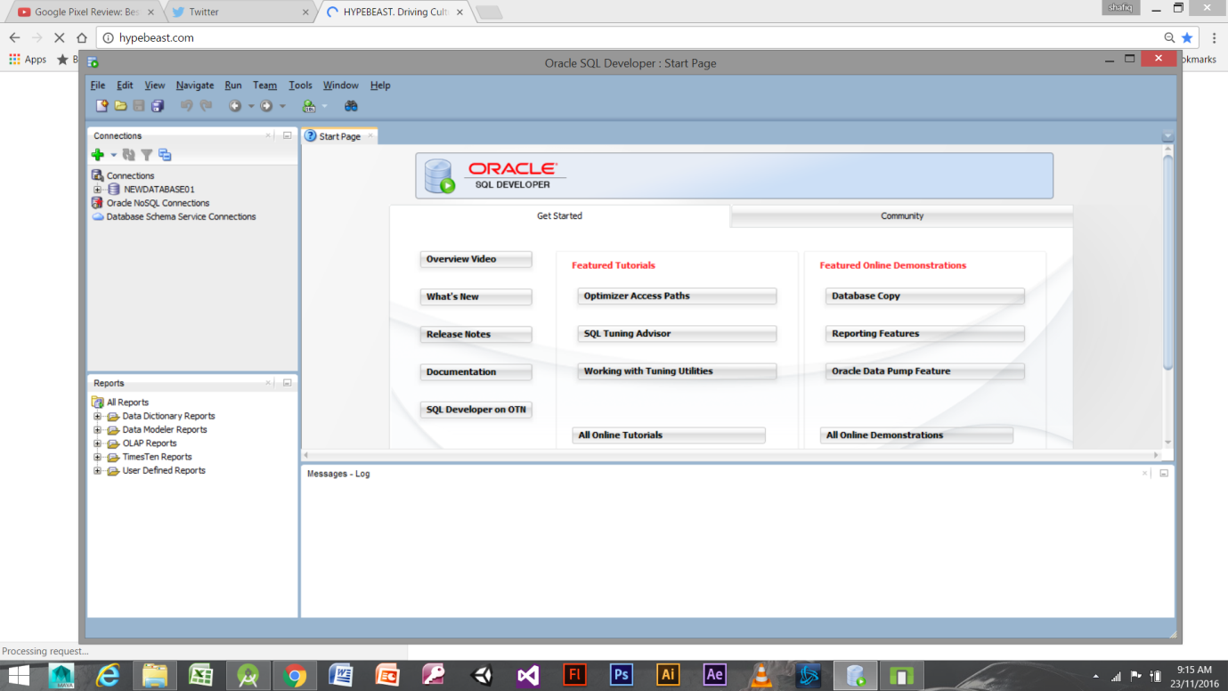

STEP 4 THIS IS HOW IT LOOKS LIKE

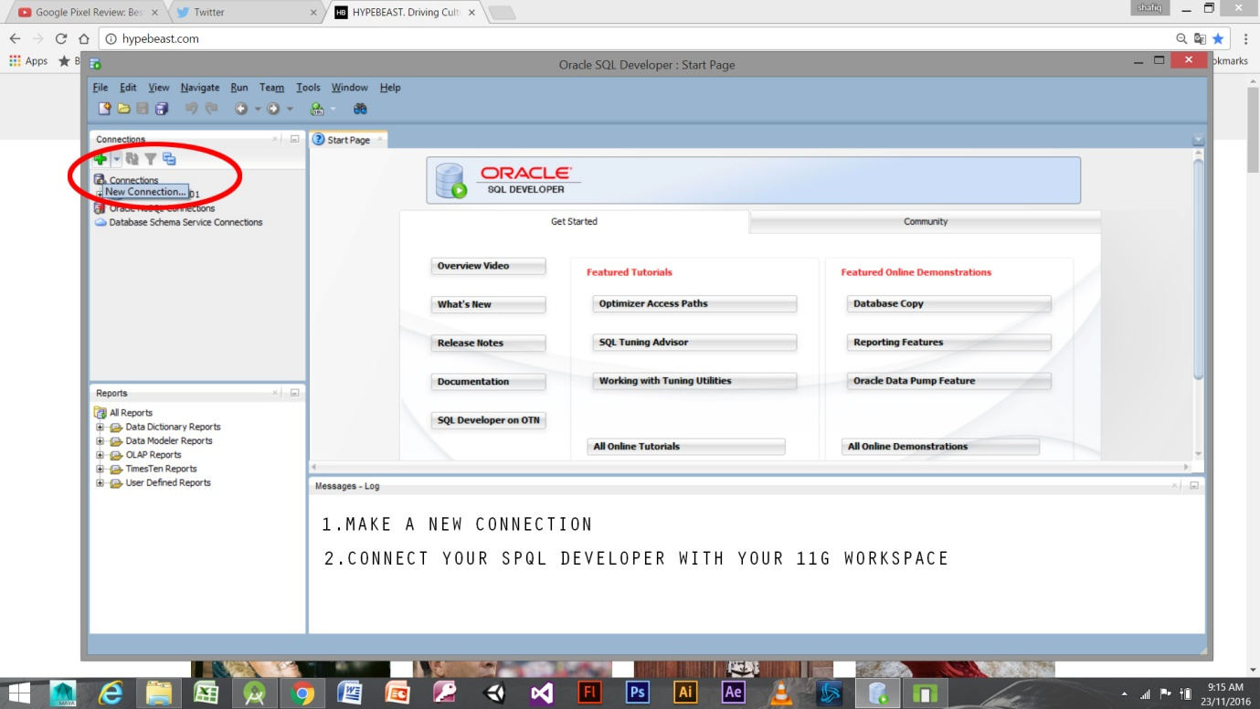

STEP 5-MAKE A NEW CONNECTION  
  
  
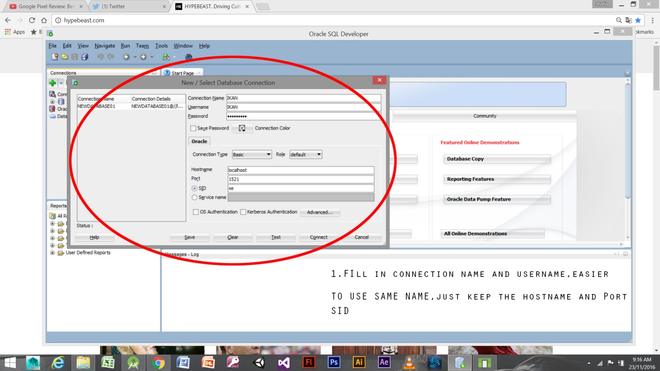

STEP 6 FILL IT UP

AND YOU MANAGE TO CONNECT YOUR ORACLE 11 G WITH YOUR WORKSPACE. CONGRATULTIONS.

CREATING TABLES

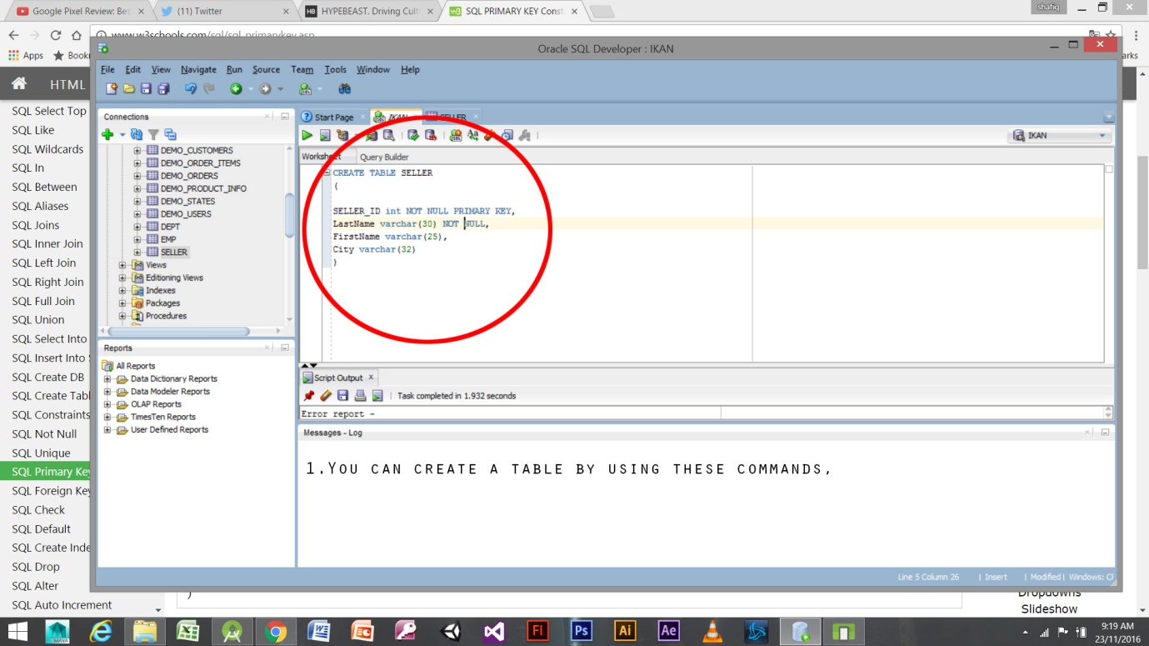

INSERT THESE COMMANDS TO CREATE YOUR OWN TABLE.

EXPLANATION

SELLER_ID IS COLLUMN NAME

Int is DATATYPE OF THE COLUMN

PRIMARY KEY IS MAKING SELLER _ID A PRIMARY KEY

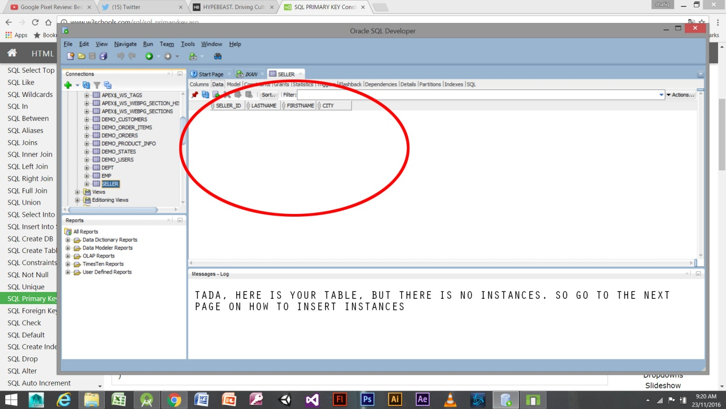

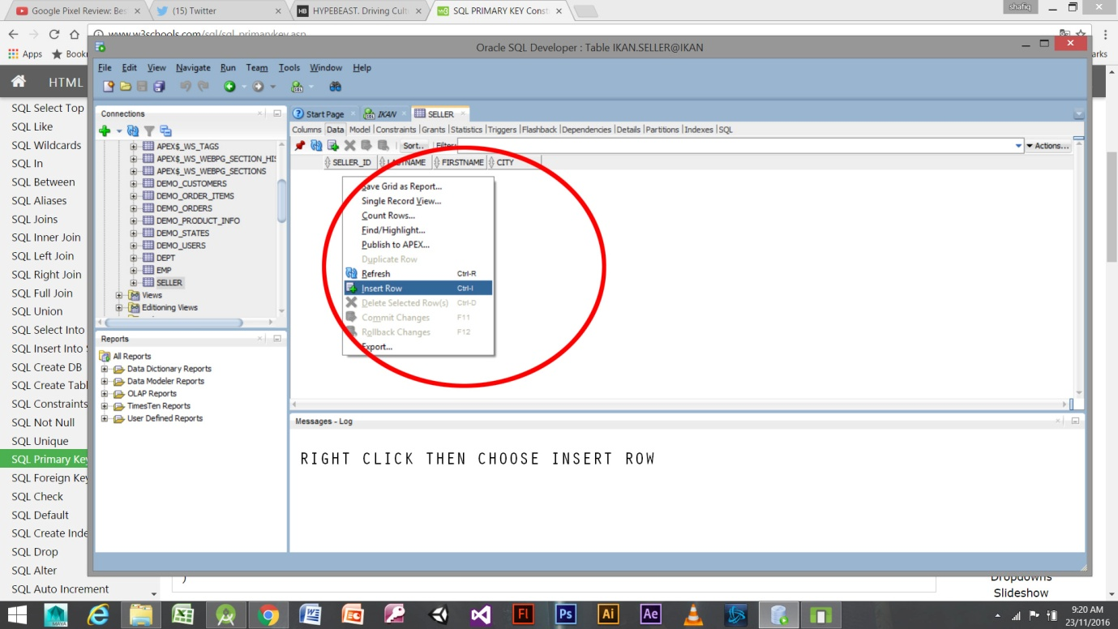  
CLICK ON THE SELLER TABLE(OR TABLE THAT YOU NAMED) AND CHOOSE DATA, THEN RIGHT CLICK AND PRESS INSERT ROW TO INSERT YOUR INSTANCES

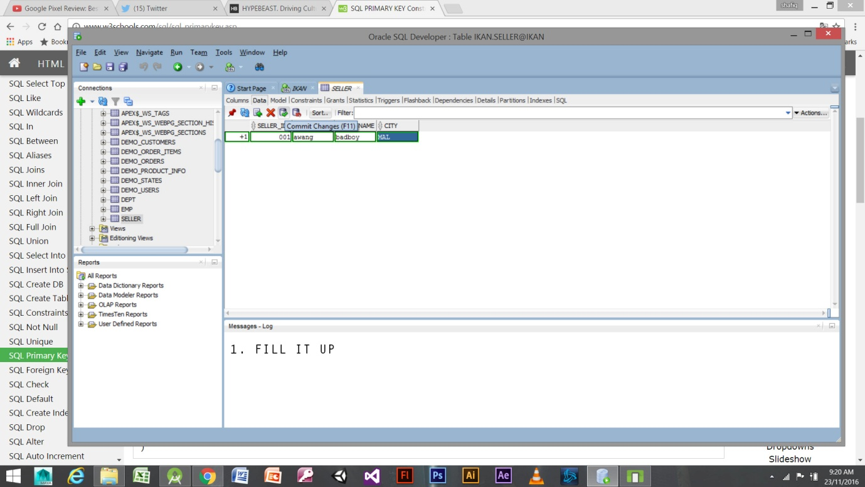  
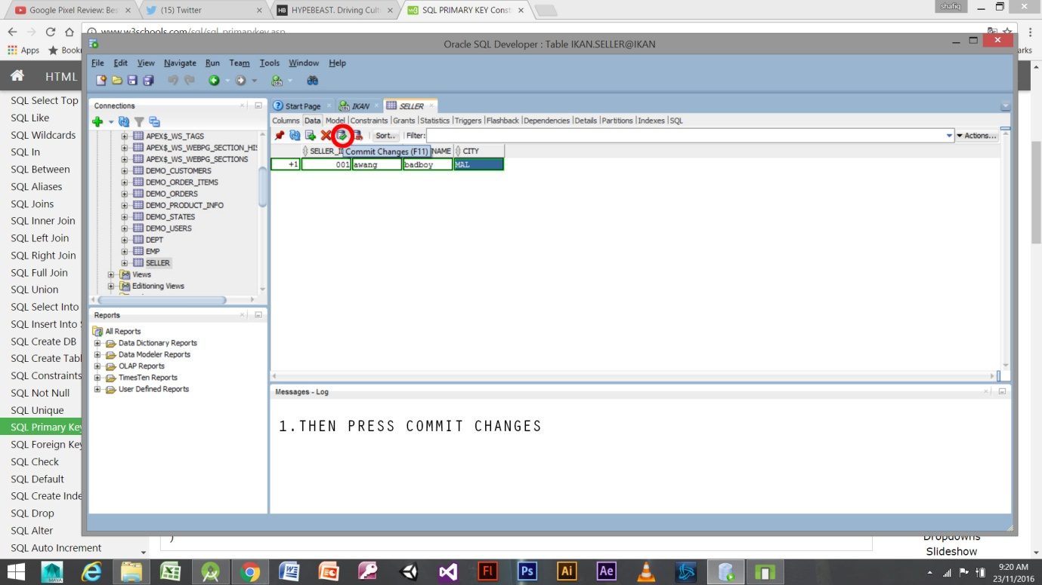

2nd way to create table in sql developer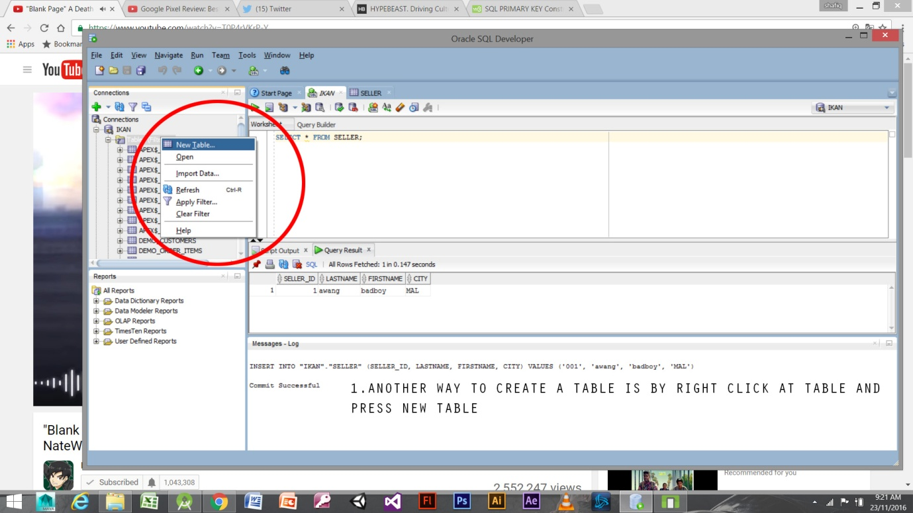  
STEP 1  
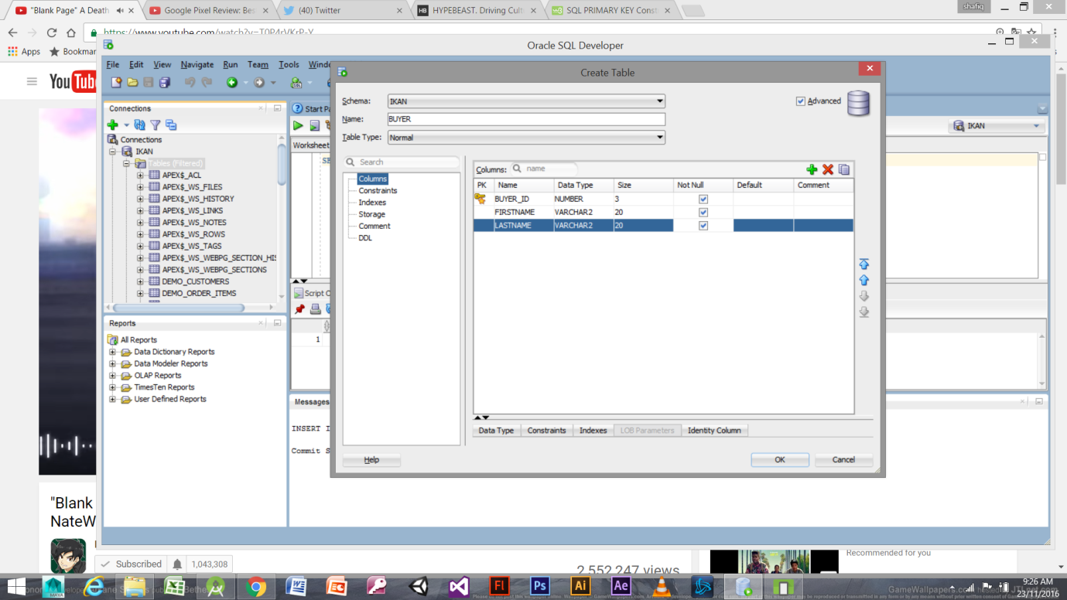  
STEP2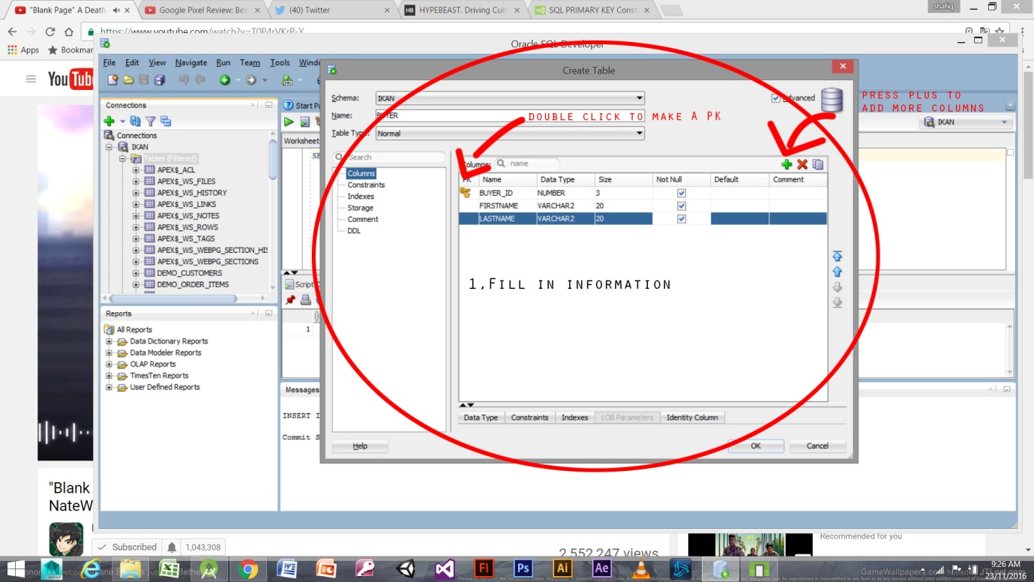  
STEP 3  
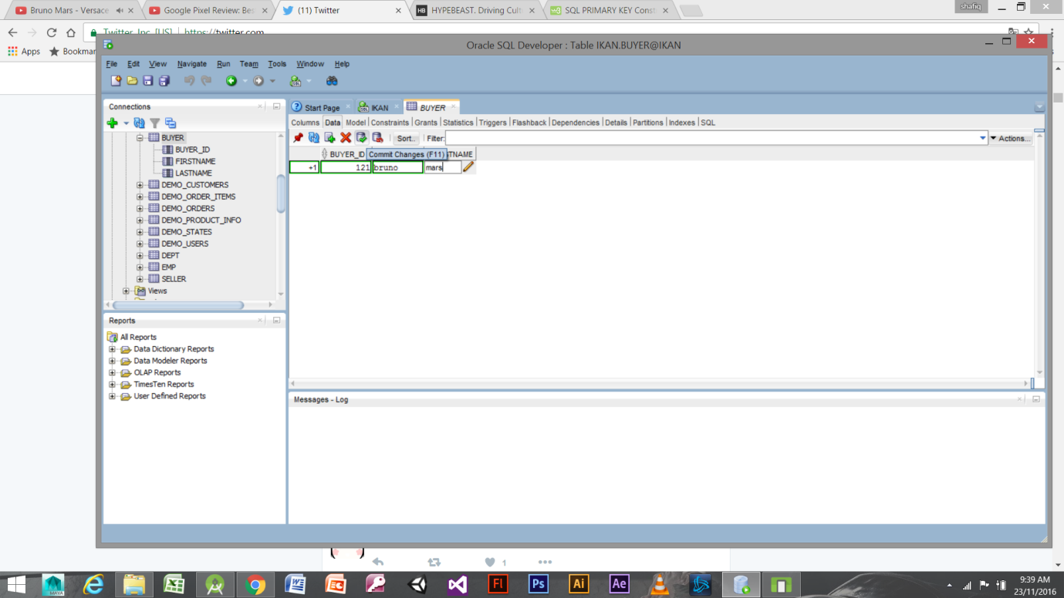  
STEP 4

ADDING INSTANCES IN THE TABLE IS THE SAME. DON’T FORGET TO COMMIT CHANGES.